 

**2024 Tournament Schedule**

30 March (Sat) Chickahominy (Rte 5)

13 April (Sat) Kerr Lake (Eastland Creek)

14 April (Sun) Lake Gaston

18 May (Sat) Pamunkey River (Williams Ramp)

15 June (Sat) Chickahominy (Rte 5)

27 July (Sat) Chickahominy (Rte 5) OPEN

10 August (Sat) Appomattox/James River (Osborne Landing)

7 Sept (Sat) Kerr Lake (Eastland Creek)

13 October (Sun) Member Appreciation No Entry Fee Tournament - Chickahominy (Rte 5)

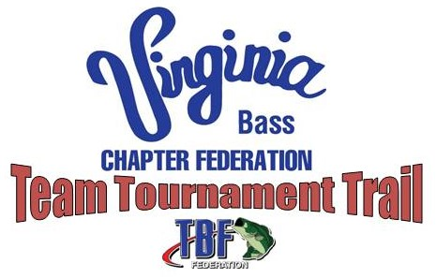

**Virginia Bass Chapter Federation Team Trail Tournament Dates:**

**East Regional**: CHICKAHOMINY RIVER, 4 Nov 2023, Chickahominy Riverfront Park (Rte 5)

**West Regional**: Smith Mountain Lake, 2 March 2024, Parkway Marina

**North Regional**:  LAKE ANNA, 20 April 2024, Sturgeon Creek Marina

**South Regional**: KERR LAKE, 4 May 2024, North Bend Special Events Area

**2024 State Team Tournament Trail Championship**:  LAKE GASTON, 1-2 June 2024, Holly Grove Marina

**TBF National Semi-Final Tournament:**

September 20-22, 2024 Hosted by VA Bass Chapter Federation on Kerr Lake

***NOTE: REGION 8 Board meeting Schedule included on next page.***

**REGION 8 Board Meeting / Event Schedule:**

The monthly Board meetings are scheduled to be at Andrea’s Italian Restaurant on the 2nd Thursday evening (6:00 PM) of each month unless otherwise noted.

**2024:**

**JANUARY** 11 January Board Meeting

**FEBRUARY** 8 February Board Meeting

**MARCH** 28 March Board Meeting

**APRIL** 9 April Board Meeting

**MAY** 16 May Board Meeting

**JUNE** 13 June Board Meeting

**JULY** 11 July Board Meeting

**AUGUST** 8August Board Meeting

**SEPTEMBER** 3 September Board Meeting

**OCTOBER** 10 October Board Meeting

**NOVEMBER** 7 November Board Meeting

**DECEMBER** 12 December Board Meeting

**EVENTS**

Bass Pro Shops (BPS) Hampton Spring Fishing Classic Support 7-27 March

Reel Kids Casting Skills Competition at BPS Hampton 23-24 March